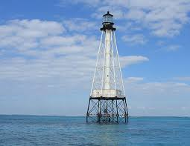 

**Matecumbe United Methodist Church**

***“Bringing the Light of Jesus Christ to Our Islands”***

** November 2018**

**From the Pastor’s Desk:**

The year was 1637 and the place was Eilenbery, Germany and all of Eurpope were at war. Eilenbery had sustained heavy damage in three separate attacks and thousands of refugees arrived adding to the chaos. Luxuries disappeared, food was scarce, disease was rampant and life was extremely difficult. Rev. Martin Rinkard was the only pastor in that community and his journal records that in one year, he conducted more than 4500 funerals. One of the occupying armies even demanded tribute payments from already impoverished people. It would seem that there was nothing for which to be grateful. No earthly reason to be thankful and yet, in that same year (1637), Pastor Rinkard wrote these words: *“Now thank we all our God, with hearts and hands and voices. Who wondrous things hath done. In whom His world rejoices; Who, from our mother’s arms, hath blessed us on our way, with countless gifts of love, and still is ours today.”* It’s a song that more than 350 years later can be found in the United Methodist Hymnal (p. 102). We all face times when life seems unfair, yet as we approach the Advent season, we are reminded there is hope. In the words of the Angel Gabriel to Mother Mary, “Nothing is impossible with God.” Celebrate this Christmas season with joy, peace, and hope. “Now thank we all our God.” Tue, Sep 3, 2013 at 12:16 PM

Tue, 12:16 PM

[Message starred](http://us.mg205.mail.yahoo.com/dc/launch?.partner=sbc&.gx=1&.rand=f5c1ipiv94i52)

**Charge Conference Forms are now online!**

FROM FLUMC-SE TO recipients

[Hide Details](http://us.mg205.mail.yahoo.com/dc/launch?.partner=sbc&.gx=1&.rand=f5c1ipiv94i52)

From

* [FLUMC-SE](http://us.mg205.mail.yahoo.com/dc/launch?.partner=sbc&.gx=1&.rand=f5c1ipiv94i52)

Greetings,

Just a quick reminder-Charge Conference Forms are available online, [click here](http://www.flumc2.org/pages/detail/2328) for the link.

Also, when accessing the 2013 charge conference forms, please be sure you click on South East District to insure that you have the specific instructions as outlined by Craig.

If you have any questions about the schedule, instructions or agenda for Charge Conference, please don’t hesitate to call the district office.

In *HIS* Service,

**Tasha L. Smith**

**District Administrator & Assistant to Superintendent Rev. Dr. Craig W. Nelson**

**Registrar, SE District Committee on Ordained Ministry**

Florida Annual Conference of The United Methodist Church

South East District Office www.flsedistrictumc.com

536 Coral Way

Coral Gables, FL 33134

Phone: (305) 445-9136 / Fax: (305) 442-0216

Wed, Sep 4, 2013 at 7:11 PM

Wed, 7:11 PM

[Message starred](http://us.mg205.mail.yahoo.com/dc/launch?.partner=sbc&.gx=1&.rand=f5c1ipiv94i52)

**Your Invoice is Ready**

FROM Billpay@AdvancedDisposal.com TO You

[Hide Details](http://us.mg205.mail.yahoo.com/dc/launch?.partner=sbc&.gx=1&.rand=f5c1ipiv94i52)

From

* [Billpay@AdvancedDisposal.com](http://us.mg205.mail.yahoo.com/dc/launch?.partner=sbc&.gx=1&.rand=f5c1ipiv94i52)

To

* [matumc@bellsouth.net](http://us.mg205.mail.yahoo.com/dc/launch?.partner=sbc&.gx=1&.rand=f5c1ipiv94i52)

Dear Customer,   
  
Your current Advanced Disposal invoice is now available to view online.   Please click on the link below to access our website.  
  
[www.AdvancedDisposal.com/billpay](http://www.advanceddisposal.com/billpay)

Invoice Information:

Account/Site Number W4003209-0000

Invoice Number W40000038307, Invoice Date 2013-08-31

Invoice Amt 20.00, Due Date 2013-09-16

If you have any questions, please contact your local Advanced Disposal office.  
  
Best Regards,  
Advanced Disposal

Wed, Sep 4, 2013 at 7:11 PM

Wed, 7:11 PM

[Message starred](http://us.mg205.mail.yahoo.com/dc/launch?.partner=sbc&.gx=1&.rand=f5c1ipiv94i52)

**Your Invoice is Ready**

FROM Billpay@AdvancedDisposal.com TO You

[Hide Details](http://us.mg205.mail.yahoo.com/dc/launch?.partner=sbc&.gx=1&.rand=f5c1ipiv94i52)

From

* [Billpay@AdvancedDisposal.com](http://us.mg205.mail.yahoo.com/dc/launch?.partner=sbc&.gx=1&.rand=f5c1ipiv94i52)

To

* [matumc@bellsouth.net](http://us.mg205.mail.yahoo.com/dc/launch?.partner=sbc&.gx=1&.rand=f5c1ipiv94i52)

Dear Customer,   
  
Your current Advanced Disposal invoice is now available to view online.   Please click on the link below to access our website.  
  
[www.AdvancedDisposal.com/billpay](http://www.advanceddisposal.com/billpay)

Invoice Information:

Account/Site Number W4003209-0000

Invoice Number W40000038307, Invoice Date 2013-08-31

Invoice Amt 20.00, Due Date 2013-09-16

If you have any questions, please contact your local Advanced Disposal office.  
  
Best Regards,  
Advanced Disposal

Fri, Sep 6, 2013 at 8:39 AM

8:39 AM

[Message starred](http://us.mg205.mail.yahoo.com/dc/launch?.partner=sbc&.gx=1&.rand=f5c1ipiv94i52)

**Prayer request**

FROM Shirley Wilson TO You + 1 More

[Hide Details](http://us.mg205.mail.yahoo.com/dc/launch?.partner=sbc&.gx=1&.rand=f5c1ipiv94i52)

From

* [Shirley Wilson](http://us.mg205.mail.yahoo.com/dc/launch?.partner=sbc&.gx=1&.rand=f5c1ipiv94i52)

To

* [Bob Pavey](http://us.mg205.mail.yahoo.com/dc/launch?.partner=sbc&.gx=1&.rand=f5c1ipiv94i52)
* [matecumbe church](http://us.mg205.mail.yahoo.com/dc/launch?.partner=sbc&.gx=1&.rand=f5c1ipiv94i52)

Hi Pastor Bob and Pam, I have a prayer request. Will you please put Ted's brother Rob Wilson on your prayer list. He is 51 and was diagnosed with cancer yesterday. We are heading up to west palm to see him now. More tests today to see what kind it really is. Large mass in his lymph nodes in neck. Thanks for the prayers. Hope to be in church on Sunday.

Shirley

--   
Shirley Wilson

Branding and Social Media Strategist

[ShirleyWilson.com](http://shirleywilson.com/)

[fb.com/shirleywilsonsocial](http://fb.com/shirleywilsonsocial)

Are we following each other on Twitter? [@Keys2BSocial](http://twitter.com/keys2bsocial)

305-394-1987

Thu, Sep 5, 2013 at 1:41 PM

Thu, 1:41 PM

[Message starred](http://us.mg205.mail.yahoo.com/dc/launch?.partner=sbc&.gx=1&.rand=f5c1ipiv94i52)

**RE: Bulletin for Sept 8th** [***2***](http://us.mg205.mail.yahoo.com/dc/launch?.partner=sbc&.gx=1&.rand=f5c1ipiv94i52)

FROM Robert Kolb TO You

[Hide Details](http://us.mg205.mail.yahoo.com/dc/launch?.partner=sbc&.gx=1&.rand=f5c1ipiv94i52)

From

* [Robert Kolb](http://us.mg205.mail.yahoo.com/dc/launch?.partner=sbc&.gx=1&.rand=f5c1ipiv94i52)

To

* [matecumbe church](http://us.mg205.mail.yahoo.com/dc/launch?.partner=sbc&.gx=1&.rand=f5c1ipiv94i52)

Pam

Let me know how this looks because I had to convert to Microsoft Word to read/edit this.  My edits are in red; some are grammatical but some are just personal preference.

Thanks

Rob

**From:** matecumbe church [mailto:matumc@bellsouth.net]   
**Sent:** Thursday, September 05, 2013 11:39 AM  
**To:** Robert Kolb  
**Subject:** Bulletin for Sept 8th

Rob -

Attached you will find the bulletins for this week. Please send me any revisions for printing on Friday!

 Richie will be playing piano. Any questions let me know.

Thanks

Pam

**Attachments**

* Bulletin Announcement sept8.wps
* Bulletin General Sept 8 2013.wps

[Download All](http://us.mg205.mail.yahoo.com/dc/launch?.partner=sbc&.gx=1&.rand=f5c1ipiv94i52)

Thu, Aug 22, 2013 at 3:06 AM

Aug 22

[Message starred](http://us.mg205.mail.yahoo.com/dc/launch?.partner=sbc&.gx=1&.rand=f5c1ipiv94i52)

**Shipment Confirmation #671675960-001**

FROM OfficeDepotOrders@officedepot.com TO You

[Hide Details](http://us.mg205.mail.yahoo.com/dc/launch?.partner=sbc&.gx=1&.rand=f5c1ipiv94i52)

From

* [OfficeDepotOrders@officedepot.com](http://us.mg205.mail.yahoo.com/dc/launch?.partner=sbc&.gx=1&.rand=f5c1ipiv94i52)

To

* [MATUMC@BELLSOUTH.NET](http://us.mg205.mail.yahoo.com/dc/launch?.partner=sbc&.gx=1&.rand=f5c1ipiv94i52)

***Pastor Bob Pavey***



**Matecumbe United Methodist Church**

81831 Overseas Highway

Islamorada, Fl 33036

**Mailing Address**

P.O. Box 905

Islamorada, Fl 33036

**Worship Service**

Sunday - 11:00 a.m.

**Adult Sunday School**

Every Sunday - 9:30 a.m.

Fellowship Center

**Office**

Phone - (305) 664-3661

E-mail - [matumc@bellsouth.net](mailto:matumc@bellsouth.net)

Website - matecumbeumc.org

Hours – Monday, Tuesday, Thursday & Friday

8:00 a.m. - 2:00 p.m.

**MATECUMBE MEMORIAL GARDENS:**

A place of remembrance for loved ones

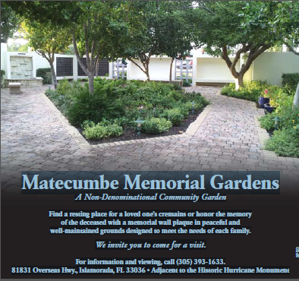

Matecumbe Memorial Gardens is a non-denominational place of rest and remembrance for loved ones. You can choose to purchase a two person cremation niche for $3000.00 with perpetual care or a memorial plaque for $500.00 in remembrance of a loved one.

For more information and to visit the Garden, please contact Donna at 305-393-1633 or Debbie at the church office.



**WORSHIP TEAM**

The worship team is currently preparing music for Christmas! Join us for practice Wednesdays at 7PM! Snowbirds are welcome.



**Children’s Home** – Start thinking about helping “our” kids for Christmas. Gift cards will be collected (so if you can pick up one or two) from Walmart, Kohl’s, Gamestop, Golden Corral, Chick-Fil-A or McDonalds in $10, $20, $25 or $50 denominations to fill their stockings or let the house parents treat them at a restaurant for a special occasion. Please drop them in the red stocking in the Narthex. Dec. 2nd is the deadline for donations. Also, thank you! So far in 2018 we gave $1782.50!

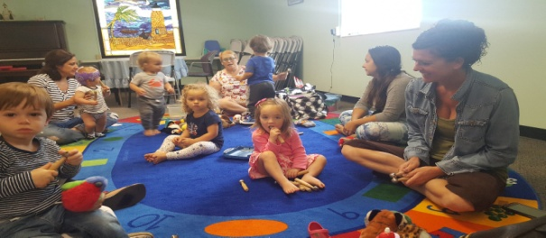

**MUSIKGARTEN:** is held Mondays at 10:00AM and will be in the upgraded Classroom and taught by Jan Grewe. MUSIKGARTEN is a musical playtime for babies through 5. The class fosters mental, social, and emotional development.

Jan is recovering from a broken leg so we are hoping this improved room will make it easier for her to have fun with the babies.



**Ladies Christmas Tea & Auction**

Dec. 8, 2018 – starting at 11:30am. Tickets are $15.00. Guest speaker to be announced soon.

There will be a silent auction and a purse auction (some have surprises in them). We appreciate all donations you can make and are in need of items large and small and / or a gift certificates from any business.

If you want to decorate a table, contact the office or Marcia Pavey. There are still 8 tables available. All funds from this event go towards missions and local community outreach.



**BOOK CLUB: Is going full force, every month! Our library is getting plenty of use and if you want to be a part, just ask Barbara Haudenshield or Marcia Pavey for more information.**

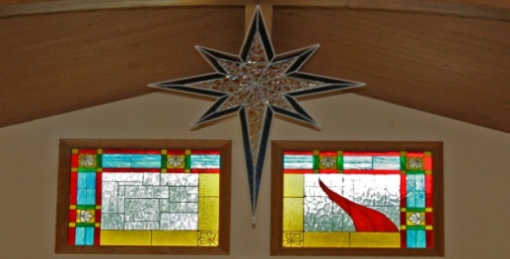

**Stained Glass Update**

The window and door for the Classroom / Musik Garden room will be replaced with hurricane glass soon. Thank you Stained Glass!

The stained glass room will be closed for some re-organization until the first meeting in January. At this meeting, a schedule will be set for safety training of new “students” and review for established groupies. Time and date of meeting TBA.

Donations for sponsorship of the new windows are still being accepted. Contact Judy Winstel at 305-304-4945 if you are interested.



**OFFICE REPORT:**  Debbie Williams

I am enjoying each and every day I get to spend in the office and meeting members here at MUMC. We want to start doing some member profiles for upcoming Newsletters. These profiles would give us more insight into what makes each of you special. If you would like to participate, there will be forms coming soon in the Narthex.

Example of a couple of questions –

*What is your favorite hymn/Bible verse? My favorite hymn (Lutheran) is Thy Strong Word, *Favorite verse: Philippians 4:6.

*Any special story? When I was in the 3rd grade, I got a pen pal also named Debbie from Sydney, Australia. We met (I have been to Australia 3 times & Debbie along with her family has been to the US once). We now Skype & email – 45 years now.

We also want to know what you would like us to be doing – special services, etc. Each and every one of you makes up the MUMC family.

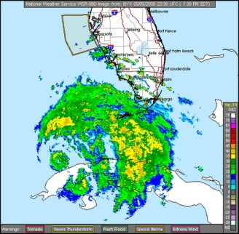

**Hurricane Irma Update One Year Later**

We have had a very busy year repairing or replacing since Hurricane Irma impacted our community on Sept. 10, 2017, The Nomads came to help with our roof in the Fellowship Hall, but we continued to have problems, so the experts at Lindholm Roofing were needed. The carpet in the Fellowship Hall had been wet and dried so much, causing mold problems that it was time to remove and upgrade to clean bright tile. Concept Tile did the work and this definitely was an upgrade that we needed to add special projects to assist the insurance portion. Concept did such a nice job, we tiled the floor in the Classroom / soon to be Musik Garden room. (This had been needed for a long time).

The parsonage complete and this is where your donations of time and money have helped the most. Pastor Bob & Marcia and the whole congregation can’t thank all of you enough. New electrical, tile, drywall, kitchen appliances, furniture, lawn & landscaping, shed, and painting had to be done and looks like it finally is.

Also, thanks to everyone who gave to the Hurricane relief fund. Since the insurance didn’t meet 100% (Jim did his best) everyone stepped up.

Hopefully, we will not have another hurricane for a long time and won’t have to rebuild, repair or replace and we can spend more time praising God and having fun and fellowship. Alma has seen her quota of hurricanes.



If you have any church appropriate jokes, funny stories, etc., please give them to Debbie and they might make it in the bulletin from The Church Mouse.



April, May, June, July, August & September **Birthdays**:

04/03 – Donna Lindback

04/11 – Joy Russell

04/22 – Alma Dalton

04/23 – Vicki Cochrane & Toni Kenworthy

04/24 – Arlene Martin

04/27 – Claude Allen

05/04 – Carol Majors

05/24 – Debbie Williams

05/25 – Joan Byrd

06/06 – Carol Schweitzer & Victoria Kattel

06/08 – Judith Sunderland

06/11 – Borden Makepeace

06/27 – Jeanne Munro

06/28 – Paul Grewe

07/08 – RJ Lindback

07/18 – Alibeth Wilson

07/24 – Chuck Dugger

07/25 – Mary Russell

07/26 – Donna Cockerham

07/27 – Linda Quinn

08/04 – Capt. Ronald Wagner

08/15 – Makena Woolet-Stockton

08/30 – Daniel Cockerham

**Anniversaries**

05/01 – Linda & Larry Balog

05/25 – Cale & Margie Smith

06/09 - Annette & Robert Pali

06/14 – Jack & Jean Munro

06/16 – Bob & Linda Quinn

06/21 – April & Chuck Dugger

08/15 – Jim & Judy Winstel

09/24 – Carl & Marlene Lindback

**Trustees’ Reports**

#1. The trustees met on Oct. 23rd with 6 members present and reviewed the repairs needed at the church and grounds. A waiver of liability for the stained glass room was created. Security lights were replaced. These were needed due to a makeshift homeless camp was set up on the north end of our building. Pastor Bob wrote them a nice note to remove their items and the Islamorada Sheriff’s office is patrolling and watching over our building a bit more closely. Two lights were replaced on the US 1 church sign. The old PA system was removed in preparation for the new sound system which has arrived and will be installed soon. A special thanks to those who worked on this especially Rich Russell and Jennifer Leak. We will no longer have cords and wires and TV screens will be mounted for song lyrics and presentations. We are so excited that our “sound” will be improved. Thanks again to everyone who donated to this project and those memory donations were made in honor of this year – Juanita Knudsen and Bill Coon. **Bob Baad**

#2. We have, for a number of years now attempted to fix our Bell Tower leak. We have re-roofed the area around it as well as seal all visible entrances through which driven rain could visibly get in. Our dear friend Jay Amman and I have put in many hours of effort on this project. It is better but continues to leak particularly during heavy rain storms. We have requested a bid from a highly regarded firm that specializes in this kind of work. This bid would require removing the coral from the tower & with pressure guns remove the loose cement around each concrete block making up the tower and then replacing it & resealing it with a specialized sealant product used on in-ground concrete swimming pools. The cleaned coral will then be reattached after this step. The entire tower will then be repainted. We realize that the cost of this being $21,600, is very significant to us. In addition our church is facing a higher bill this year for our property & casualty insurance in Jan. We expect it to be much higher than last year. We don’t know yet.

We feel however that this investment should be made. We wish to appeal to you, our members & friends to donate specifically to this very worthwhile cause. We hope that you might wish to make a specific donation to this needed effort to keep our sanctuary the beautiful landmark here in Islamorada that it has become. Thank you. **Jim Winstel**



Memory of the Matecumbe UMC Family who we have lost (and are in heaven) in 2018. **Juanita Knudsen, Carl Lindback and Bill Coon.**

They will always be loved, missed and never forgotten.